Policy Statement - At Little Wings Big Dreams, our utmost responsibility is ensuring the safety and welfare of the children, as well as the well-being of their parents and the broader community. Safeguarding is integral to our Ofsted registration, and it serves not only to protect and promote children's welfare but also to instil confidence in our staff, volunteers, parents, carers, management, and the public. Our primary objective is to create a nurturing and child-centred environment where children can have fun while remaining safe. We are committed to preventing and responding to concerns related to child abuse, including physical, sexual, emotional, neglect, and domestic abuse. Children have the right to be protected from harm. Our room layout ensures constant supervision, preventing one-on-one situations between children and staff or volunteers without the presence of others. Key elements of child safety are integrated into our programme to support children's personal, social, and emotional development, fostering their resilience and understanding of how to stay safe. We create a culture of value and respect for individuals, celebrating diversity in heritage, ethnicity, languages, culture, and social background.

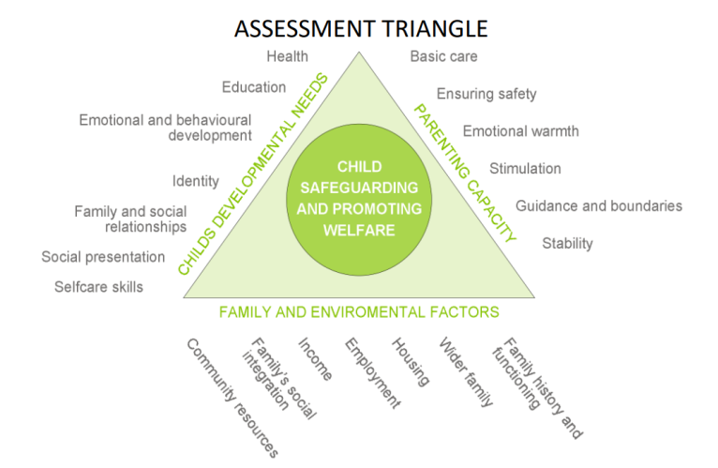
Safeguarding and Welfare Requirements: We adhere to the ten overarching Safeguarding and Welfare Requirements within the EYFS, which cover child protection, suitability of staff, qualifications and training, key persons, health, behaviour management, premises and equipment safety, special educational needs, information and records, and policies and procedures.

Procedures- Please find our safeguarding procedures that act as guidelines and instructions that explain the steps that our organisation will take to keep children safe and what to do when there are concerns about a child's safety or wellbeing.
The assessment triangle highlights everything that must be considered within child protection and welfare.
Training: All staff must complete Level 2 and Level 3 safeguarding training and our personalised mandatory training programme during their induction period. Alongside this they will also be enrolled onto the Local Authority’s Safeguarding Training to include training on Local Protocols. Please see our safer recruitment policy for further details on how we take these procedures into account to safeguard children.
Bexley S.H.I.E.L.D: A statutory multi-agency partnership which brings together the key organisations that collectively hold responsibility for safeguarding children and young people in Bexley. In line with statutory guidance (Working-together-to-safeguard-children) https://www.gov.uk/government/publications/working-together-to-safeguard-children--2, the partnership replaced Bexley Safeguarding Children’s Board in October 2018. https://bexleysafeguardingpartnership.co.uk/about-partnership/

Procedures:
All staff are familiar with procedures for reporting and recording concerns, and at least 1 Designated Safeguarding Lead (DSL) is named and trained within the setting at all times. If a staff member has a concern about a child they should report this to the DSL and manager in both a verbal and written format as soon as reasonably possible. Details of The nursery’s Safeguarding officers are found on posters in multiple locations throughout the nursery and on the website. Little Wings Big Dreams undergo on-going regular training to stay updated on child protection and relevant legislation https://www.gov.uk/government/publications/keeping-children-safe-in-education--2.
Recording Suspicions of Abuse and Disclosures: When a child makes a disclosure about something that has happened or staff observe signs of concern, we follow procedures that prioritise the child's well-being and safety. Our team are trained to ask open ended questions and give children the time they need to confide in the staff member: supporting them emotionally.

If a child comes in with a pre-existing injury in an uncommon area (as per the body map on the staff board) staff are trained to be intuitive and ask them how it happened. Pre-existing injuries especially for immobile children and babies can be a significant sign of physical abuse at home. All pre-existing injuries are reported to our DSL or DSO. Information is recorded on a confidential safeguarding form, including date, time, exact words spoken, names of those involved, and is kept securely and confidentially. The DSL is informed promptly.

Responding to Suspicions of Abuse:

We acknowledge that child abuse can take various forms. We recognise the additional vulnerabilities arising from special educational needs, disabilities, race, gender, language, religion, sexual orientation, or culture. Signs of abuse may include changes in behaviour, deterioration in well-being, comments raising concerns, unexplained injuries, changes in appearance or behaviour, and more. We refer children who meet the criteria of a child in need under the Children Act 1989 to local authority children's social work services.

Normally, parents are the first point of contact, and any concerns are discussed with parents to gain their perspective in a confidential and private discussion. In cases which are rated level 3 or above using the Effective Support Document, where external agency intervention may be required parents are informed. Concerns will be discussed and then followed up with a duty Social worker from the MASH team if certain criteria is met through a safeguarding investigations. The only time a parent will not be informed is when the child may seem in danger from the parent or if it would interfere with an on-going investigation. In this case a safeguarding form will be hand written and placed in a the childs confidential file in the office, with all follow up advice recorded and dealt with following advice from the Social worker. If at any time the DSL is not satisfied with the outcome of the phone consultation, the completed referral form through MASH and the team should respond within 24 hours. It is then down to the nursery DSL to chase feedback from this referral.

Staff can talk through worries with the safeguarding lead and if they believe that action to safeguard a child has not been taken appropriately they can:

- Call Children’s Services at the Multi-Agency Safeguarding Hub (MASH) on Tel: 0203 045 5440 (MASH) and ask for a consultation with a social worker. The opening hours are Monday to Friday 9am to 5pm
If staff believe that action against a staff member was not dealt with in line with the setting’s Whistleblowing procedures they can:
- Contact LADO (Local Authority Designated Officer) on Tel: 0208 3037777

Voluntary or paid professionals can’t make an anonymous referral. Unless there’s a significant reason not to you should discuss your concerns with the child’s parent or guardian and let them know you’re thinking about talking to Children’s Services. Then complete the referral form through MASH and the team should respond within 24 hours. It is then down to the nursery DSL to chase feedback from this referral.

Allegations Against Staff and Persons in Positions of Trust: Staff, volunteers, and anyone working at the setting know the process for raising concerns. We ensure parents and visitors are aware of how to report concerns about staff or volunteers within the setting by sharing our whistle blowing policies and procedures on the Famly app and having contact details of the DSL readily available on the website. We respond to allegations of harm to a child by a person in a position of trust by reporting them to our Designated Safeguarding Lead. If this is not dealt with then to upscale it to a member of management and if not dealt with again then to the Local Authority Designated Officer (LADO). Tel: 0203 045 3436 (LADO Team)

When any written LADO referral incident has been reported through the link: https://bexleysafeguardingpartnership.co.uk/for-professionals/local-authority-designated-officer/
Ofsted must also be notified through the link:
https://www.report-childcare-incident.service.gov.uk/serious-incident/childcare/update-incident/

Anonymity and Confidentiality: Suspicions and investigations are kept confidential and shared only with those who need to know, following guidance from local safeguarding partners and GDPR regulations. Those reporting concerns to Ofsted or children's services can request confidentiality.

